1 INTRODUCTION

The seventh report of the Joint National Committee on Prevention, Detection, Evaluation and Treatment of High Blood Pressure defines blood pressure for adults aged 18 years. Hypertension is defined as systolic blood pressure >140 mmHg or diastolic blood pressure >90 mmHg. The classification of hypertension is based on the mean of two or more properly measured seated blood pressure readings. Normal blood pressure ranges below levels <120/80 mmHg. A systolic blood pressure of 120 – 139 mmHg or diastolic blood pressure of 80–89 mmHg is classified as prehypertension. These patients are at an increased risk of progression to hypertension (Gupta, 2003).

Hypertension can be classified into two stages:
- Stage 1 includes patients with systolic blood pressure 140 - 159mmHg or diastolic blood pressure 90 - 99 mmHg.
- Stage 2 includes patients with systolic blood pressure more than 160 mmHg or diastolic blood pressure more than 100 mmHg.

Hypertension is a serious problem throughout the globe due to its high prevalence and its association with increased risk of chronic kidney diseases. High blood pressure may permanently damage the narrow blood vessels in the kidney that play a vital role in the filtration of blood. Over time, this damage will keep the kidney from working properly.

Hypertension plays a vital role in accelerating the progression of experimental renal disease. Chronic kidney disease (CKD) is the most occurring form of secondary hypertension and it also suggests that it is an independent risk factor for cardiovascular morbidity and mortality (Sinclair et al., 2004). The relationship of “benign” (a misnomer) essential hypertension to renal failure is less clear. It was observed that essential hypertension tends to increase in afferent arteriolar resistance, with a lesser increase in efferent resistance, so renal blood flow (RBF) decreases, filtration fraction (FF) increases and glomerular filtration (GFR) tends to be preserved (Birkenhager et al., 1976).

There is evidence both clinically and experimentally that “blood pressure goes with the kidney” (Kuster et al., 1990; Adamczak et al., 2002). The association between hypertension and renal disease was the first recognized by Richard Bright. He observed that the extent of heart damage was at a pace with kidney damage (Bright et al., 2009). Sodium retention and activation of the renin-angiotensin system have been considered the most important mechanisms involved in the elevation of blood pressure in subjects with kidney disease (Guyton et al., 1990). High blood pressure is almost always present during all stages of chronic kidney disease. Urinalysis may show protein or other changes. These changes may appear 6 months to 10 or more years before symptoms appear. The kidney function tests analysed creatinine clearance and blood urea nitrogen levels.

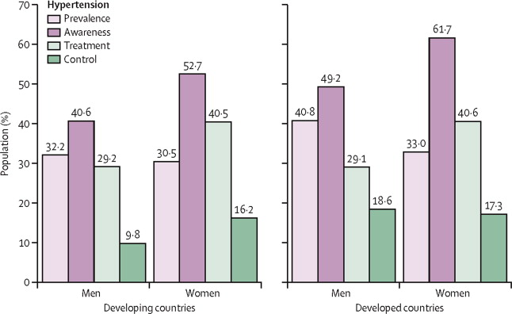
Fig 1 : Frequency of hypertension among developed and developing countries in terms of its attributes (Ibrahim and Damasceno, 2012)

It has been reported that hypertension is the seventh highest contributor to premature death in developing countries (Deepa et al., 2003). The prevalence of hypertension in developed and developing countries is very high and is increasing at an alarming rate (Fig 1). Nearly 26 % of the adult population worldwide is affected by hypertension.

Chronic kidney disease affects more than 20 million US adults, while more than 79,812 chronic dialysis patients die each year in the United States, with an annual unadjusted mortality rate of 20 to 25% (Coresh et al., 2007). The prevalence of hypertension in patients with chronic kidney disease is estimated to be more than 60%, and more than 90% in patients with advanced renal failure (Stage IV and V) (Levey et al ., 2009; Campese et al ., 2006). Based on a national survey of representative samples of non-institutionalized adults in the USA, it is estimated that hypertension occurs in 23.3% of individuals without CKD and 35.8% in stage 1 CKD, 48.1% of stage 2, 59.9% of stage 3 and 84.1% of stage 4–5 patients (Kearney et al. 2005).

As with CKD, awareness of hypertension is low. Hence, approaches to control hypertension will play a major role in the modification or prevention of chronic kidney diseases. A combination of population-wide and individual health-care interventions must control the growing epidemiology of hypertension. With this background, the present study has been undertaken to study the prevalence of hypertension and its associated factors and to increase the awareness of the importance of lifestyle modifications among rural dwellers of south India. Studies targeting low socio-economic groups would provide an estimate of the future magnitude of the problem and assist in developing strategies for controlling hypertension and chronic kidney diseases (CKD).

1.1 Present Study
To estimate the prevalence of pre-hypertension and hypertension in a rural population from Kancheepuram district of Tamil Nadu, India and their association with risk factors of chronic kidney disease (CKD)

1.2 Objectives
Until recently, hypertension was considered one of the important public health problem in the developed and industrialized countries only. In the developing countries, its impact was not fully felt due to the presence of rampant communicable diseases. However, with control with communicable disease and increased life expectancy with lifestyle changes, hypertension is becoming one of the emerging problems with its implications for the concomitant increase in the risk of cardiovascular and renal disease.

1.3 Specific Objectives
- To estimate the prevalence of pre- and hypertension in a rural population from Kancheepuram district of Tamil Nadu.
- To investigate the association of study variables such as age, gender, BMI, waist hip ratio, family history, intake of salts, smoking, alcohol intake, education, and social and economic status with the development of pre- and hypertension in the study population.
- To determine the level of serum electrolytes and the status of serum urea, uric acid, creatinine, glucose, triglycerides, cholesterol, HDL, andLDL in the study population of pre- and hypertensive patients.
- To screen and identify polymorphic or mutational changes at the homocysteine gene loci and its association as a risk factor for chronic kidney diseases in the study population of pre- and hypertensive patients by PCR-SSCP-RFLP
- To reduce the incidence of hypertensive diseases through appropriate health awareness and individual health-care interventions.

REVISION SUMMARY
File name: Trinka AI Sample File Auto Edit File.docx

Trinka scanned and edited your text for language errors and identified the areas of improvement. Here are the details.

This file had 1007 words and 52 revisions. Our initial assessment showed 51% as the language score for your uploaded file. The distribution of errors and improvements is shown below. A total of 2 suggestions have been added as comments in the document.

Category | Revisions
Abbreviations | 0
Adjectives/Adverbs | 1
Articles | 10
Capitalization & Spacing | 7
Conjunctions | 0
Difficult-to-read Sentence | 0
Enhancement | 6
Fragment | 0
Idioms | 0
Number Style | 0
Plain Language | 0
Prepositions | 3
Pronouns & Determiners | 0
Punctuation | 4
Redundancy & Conciseness | 2
Run-on Sentence | 0
Sensitive Language | 0
Singular-Plural nouns | 3
Spelling & Typos | 0
Style | 0
Subject-Verb Agreement | 0
Symbols/Notations | 0
Syntax | 0
Tense | 2
Verbs | 2
Word Form | 0
Word Order | 0
Word/Phrase Choice | 6
Other | 4
Style Guide - None | 0
Total | 52

